# Unit 5 Chapter 8 Part 2 Notes Rev1 – Combinations in Counting

## Combinations

An **r-permutation** is an **ordered arrangement or r out of n elements**, while an **r-combination is an unordered subset of r out of n elements.**

### Combinations vs Permutations

#### Permutations

* When the **order doesn't matter**, **it is a Combination**.
* When the **order does matter** it is a **Permutation**.
  + Example: A safe number combination is 8, 1, 3. The order is mandatory to open a safe.
  + There are **2 types of Permutation**: **Repetition** and **Non-Repetition**.
    - A lock combination: “222” – **Repetition**.

For example: choosing ***3*** of those things, the permutations are:

**n × n × n***(n multiplied 3 times)*

More generally: choosing ***r*** of something that has ***n*** different types, the permutations are:

**n × n × ...*(r times)***

(In other words, there are **n** possibilities for the first choice, THEN there are **n** possibilities for the second choice, and so on, multplying each time.)

Which is easier to write down using an exponent of **r**:

**Formula: n × n × ... (r times) = nr**

* + - * Example: For a lock number selection, there are 10 numbers to choose from (0,1,2,3,4,5,6,7,8,9) and we choose 3 of them:

10 × 10 × ... (3 times) = 103 = 1,000 permutations

* + - Olympic race: Only a first place winner, a second place winner and a third place winner – **Non-repetition**.
      * We have to reduce the number of available choices each time.
      * What order could 16 pool balls be in?

After choosing, say, number "14" we can't choose it again.

So, our first choice has 16 possibilities, and our next choice has 15 possibilities, then 14, 13, 12, 11, ... etc. And the total permutations are: **16 × 15 × 14 × 13 × ... = 20,922,789,888,000**

But maybe we don't want to choose them all, **just 3** of them, and that is then: **16 × 15 × 14 = 3,360**

There are 3,360 different ways that 3 pool balls could be arranged out of 16 balls.

**Formula: $\frac{n!}{r!\left(n-r\right)!}$**

Where n is the number of things to choose from, and we choose r of the number things, no repetitions, order matters.

|  |  |  |  |  |
| --- | --- | --- | --- | --- |
| **16!** | = | **16!** | = |  |
| **3!(16-3)!** | **3!*13!** |

(Which is just the same as:**16 × 15 × 14 = 3,360**)

Example:

Consider our “errands” examples from the previous section. If ***one had to choose two*** ***out of four possible errands***, there are **P(4, 2) = 4 · 3 = 12** such ***ordered arrangements (r-permutations***). Note that ***such permutations distinguish between identical subsets of errands if they appear in a different order***; e.g., ***(grocery store, post office) is different from (post office, grocery store)*** since the errands are processed in a different order. If order did not matter, then these two “arrangements” would be identical and ***denoted with set notation {grocery store, post office}.***

Such a subset is a 2-combination. More generally, an unordered subset of r elements out of n is an r-combination, and the number of such combinations is denoted Choosing formula in combinatoricsCalculators often use the notation nCr analogous to nPr for r-permutations. Finally, Binomial coefficient.is often referred to as a binomial coefficient.

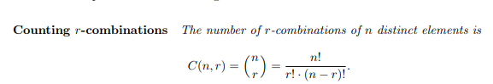

**Proof: P(n, r) = C(n, r) · P(r, r)**. That is, to create **an ordered list of r elements from a set of n elements**.

1. First, ***choose r elements from the set (there are C(n, r)*** ways to do this
2. Then, choose **an ordering of the r elements** (there are **P(r, r)** ways to do this). Since we already know that **P(n, r) = n!/(n − r)!** and **P(r, r) = r!**, the result follows.

Choosing **r out of n elements to be included in a subset is equivalent** **to choosing the n − r elements** which should be left out of the subset. Therefore, **every r-combination has a unique associated (n − r)-combination**, and thus the number of r**-combinations is equivalent to the number of (n − r)-**combinations.

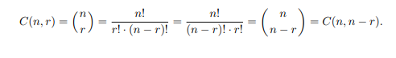

#### Combinations: Order does not matter

1. There are 2 types of combinations: **Repetition and No-Repetition**
2. **Repetition is Allowed**: such as coins in your pocket (5,5,5,10,10)

In **permutation**, choosing balls 1, 2 and 3. These are the possibilities:

| Order does matter | Order doesn't matter |
| --- | --- |
| 1 2 3 1 3 2 2 1 3 2 3 1 3 1 2 3 2 1 | 1 2 3 |

So, the permutations have 6 times as many possibilities in comparison to combinations.

Example of combinations:

There are five flavors of ice cream: **banana, chocolate, lemon, strawberry and vanilla**.

We can have three scoops. How many variations will there be?

Let's use letters for the flavors: {b, c, l, s, v}. Example selections include

* {c, c, c} (3 scoops of chocolate)
* {v,v,v} (3 scoops of vanilla)
* {b, l, v} (one each of banana, lemon and vanilla)
* {b, v, v} (one of banana, two of vanilla)

Etc…

There are **n=5** things to choose from, and we choose **r=3** of them.  
**Order does not matter**, and we **can** repeat!

*How many different ways can we select ice cream flavors?*

**Formula: $\frac{\left(r+n-1\right)!}{r!\left(n-1\right)!}$**

Where **n** is the number of things to choose from, and we choose **r** of them repetition allowed, order doesn't matter.

Choosing 3 of 5 flavors of ice-cream:

= $\frac{\left(3+5-1\right)!}{3!\left(5-1\right)!}$ **= $\frac{7!}{3!*4!}$ = 35**

## Ball in Bins

Suppose that there are **60 students in a discrete math class**, and we recorded each student’s birthday. Surprisingly, a result in probability theory known as the Birthday Paradox states that there is a greater than **99% chance that at least two people will share the same birthday**.

Now suppose that **we were to write down a tally of all 60 birthdays by date**, for example

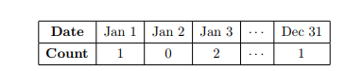

How many such tallies are there? Each tally corresponds to a unique sequence of 365 numbers whose sum is 60, such as the sequence (1, 0, 2, . . . , 1) above. This is a specific instance of what is generally known as a “balls in bins” problem: Imagine throwing 60 balls into 365 bins; how many ways can the 60 balls be placed in these 365 bins, where the only quantities of interest are the numbers of balls in each bin?

In our example, we wish to calculate the number of ways of assigning 60 students to 365 possible birthdays, where birthday repetitions are allowed.

In order to count the number of such arrangements of balls in bins, we shall consider an alternate but equivalent representation of any such arrangement. Imagine that the bins are all adjacent, and that there is a divider between adjacent bins. Let “|” represent the dividers, and let “•” represent balls. Any arrangement of balls in bins can be encoded by a sequence consisting of one • for each ball in the first bin, followed by a divider |, followed by one • for each ball in the second bin, and so on. In our example arrangement above, the encoding would be

Visual illustration of symbols combinations: 

Note the two adjacent dividers that represent the empty “bin” corresponding to Jan 2. Any such sequence will contain exactly 424 symbols: 60 • symbols corresponding to the balls and 364 | symbols corresponding to the bin dividers.1 How many such sequences are there? We have 424 total symbols, and we must choose which 60 will be • symbols (and thus which 364 will be | symbols). This is a direct application of combinations, and thus the answer is

Output of symbols and dividers combinations, approximately 6.57 x 10^73

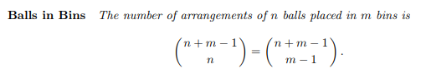

Example:

I have a box with 50 Snickers candy bars. 8 kids come over on Halloween night, to trick-or-treat.

a. How many ways can I distribute all 50 Snickers candy bars to the 8 kids?

b. How many ways can I distribute all 50 Snickers candy bars to the 8 kids if every kid gets at least 2 candy bars?

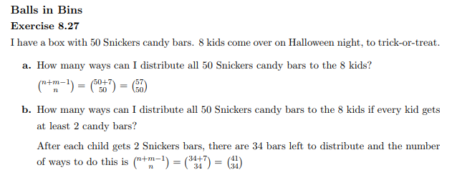

1. **No Repetition**: such as lottery numbers (2,14,15,27,30,33)

**Formula:**

Combination formula: n!/((n-r)! * r!)

When choosing 3 balls from 16 balls, we apply the formula.

So, our pool ball example (now without order) is:

$\frac{16!}{3!(16!-3!)}$ = $\frac{16!}{3!(13!)}$

= **560 variations of 3 balls being selected from the 16 pool balls**.

### Another Example:

For example, a poker hand can be described as a 5-combination (k = 5) of cards from a 52 card deck (n = 52). The 5 cards of the hand are all distinct, and the order of cards in the hand does not matter. There are 2,598,960 such combinations, and the chance of drawing any one hand at random is 1 / 2,598,960.

### Example 8.17:

Eight members of the wedding party (following example in Part 1 of Permutations) are to do a traditional circle dance. How many different groups of eight can be selected?

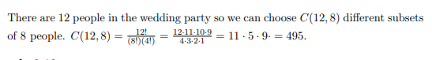

### Example 8.18:

Now that we have selected 8 people for the dance, how many ways can we arrange them in a circle?

This is a **permutation problem, not a combination problem**. It is similar, but not quite the same as finding the number of ways to arrange 8 people in a line. There are P(8, 8) = 8! ways to do that. Each circular arrangement will appear 8 times as a linear arrangement. (A B C D E F G H forms the same circular arrangement as B C D E F G H A or C D E F G H A B . . .) So **there are 8!/8 = 7!** Possible circle dance arrangements.

### Example 8.19

How many ways can I select 3 men and 3 women from the wedding party? There are 6 men and 6 women in the wedding party. The number of ways of choosing **3 men (or 3 women) is C(6, 3) = 20.** The number of ways of selecting **3 men and 3 women from the wedding party is 20 · 20 = 400**.

### Example 8.20

How many ways can I select 6 students from this class of 51 students to get a grade of ”A”?

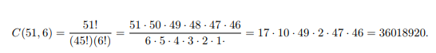

18009460

## Binomial Theorem

Binomial Theorem which allows one to expand expressions of the form **(x + y) n** for any **non-negative integer n**.

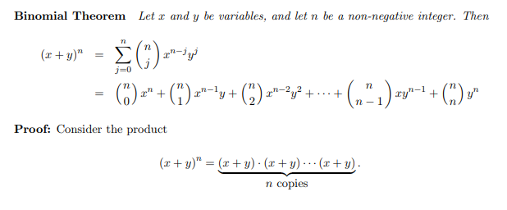

To expand this product, one could repeatedly **apply the distributive law**

**(a + b) · c = ac + bc.**

Applying the distributive law to (x+y)

**n = (x+y)·(x+y)**n−1

Or one could choose first to expand via x in the first factor, obtaining the sub-expression

**x · (x + y)n−1**

Or one could expand viay, obtaining **y ·(x + y)n−1**

Similarly for the remaining factors, one could choose to expand via x or y. The full expansion is the sum of all the expressions one obtains from making all such possible choices.

Suppose that one chooses to expand via y a total of j times, thus expanding via x the remaining n − j times. What expression results? We have j y-factors and n − j x-factors, thus obtaining the expression

**xn−j yj**

How many such expressions can one obtain?

There are n total (x + y) factors, and one must choose j of them to expand via y (and thus n − j to expand via x). This is a direct application of combinations—there are precisely Expression of choosing j from n ways of choosing j out of n factors to expand via y. Thus, the term xn−j yj will appear Expression of choosing j from n times. The complete expansion is thus the sum of all Expression of choosing j from n x n−jyj terms for all possible.

### Example 8.21

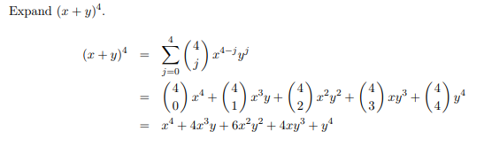

(x+y)(x+y)(x+y)(x+y)

### Example 8.22

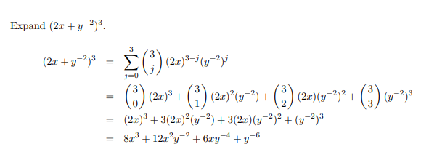

### Example 8.23

Give the term in (a + b)42 that contains the factor b17.

Example 8.23: Choosing 17 of 42 for a^25b^17.

## Pascal Triangle

Pascal’s triangle arises as a consequence of the following fact concerning binomial coefficient.

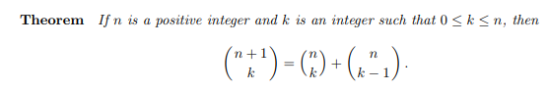

Proof: 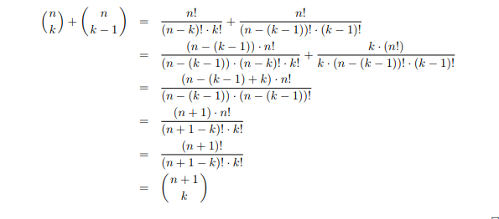

This theorem effectively says that that one can compute an entry in Pascal’s triangle by adding the two elements diagonally above it; see the diagram below.

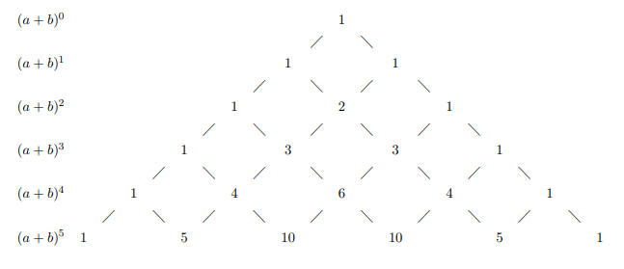

(a+b)6 1 6 15 20 15 6 1

Expand (x – y)4.

1. Take a look at Pascal's triangle.
2. From the fourth row, we know our coefficients will be 1, 4, 6, 4, and 1. That negative sign means that the first term of our expansion will be positive, and the following terms will alternate signs.
3. The exponents will start at x4y0 and move to x3y1, etc.

(x – y)4

= 1x4 – 4x3y + 6x2y2 – 4xy3 + 1y4

= x4 – 4x3y + 6x2y2 – 4xy3 + y4